|  |
| --- |
| Name:H J K I Wijerama |
| Student Reference Number:10707417 |



|  |  |  |
| --- | --- | --- |
| Module Code: ISAD254SL | Module Name: Human computer interaction | |
| Coursework Title:HCI final course work | | |
| Deadline Date:  24 / 04 / 2021 | | Member of staff responsible for coursework:  Ms.Pavithra Subashini |
| Programme: BSc(Hons)Software Engineering | | |
| Please note that University Academic Regulations are available under Rules and Regulations on the University website [www.plymouth.ac.uk/studenthandbook](http://www.plymouth.ac.uk/studenthandbook). | | |
| Group work: please list all names of all participants formally associated with this work and state whether the work was undertaken alone or as part of a team. Please note you may be required to identify individual responsibility for component parts.   * 10707417-H.J.K.Isindu Wijerama * 10707129-K.L.Dulani Anupama * 10707216-K.Charuka Heshan * 10713401-U.R.K.Ukwatta * 10707256 - N.N.D.G.Liyanage   ***We confirm that we have read and understood the Plymouth University regulations relating to Assessment Offences and that we are aware of the possible penalties for any breach of these regulations. We confirm that this is the independent work of the group.***  Signed on behalf of the group:  nn  H.J.K.I. Wijerama | | |

|  |
| --- |
| Individual assignment: ***I confirm that I have read and understood the Plymouth University regulations relating to Assessment Offences and that I am aware of the possible penalties for any breach of these regulations. I confirm that this is my own independent work.***  Signed : |
| Use of translation software: failure to declare that translation software or a similar writing aid has been used will be treated as an assessment offence.  I *have used/not used translation software.  If used, please state name of software………………………………………………………………… |
| **Overall mark _____% Assessors Initials ______ Date_________** |



**ISAD254SL-Human Computer Interaction**

Group members :

* 10707417-H.J.K.Isindu Wijerama
* 10707129-K.L.Dulani Anupama
* 10707216-K.Charuka Heshan
* 10713401-U.R.K.Ukwatta
* 10707256 - N.N.D.G.Liyanage

**Table of Content**

* Introduction

1.Introduction to project

2.Problem statement

* PACT Analysis
* User Profiles
* Task Analysis diagrams
* Lo-fidelity prototypes
* Design principles used and justification
* Prototype

1.Technical specifications

2.Screen designs with descriptions

* Usability Evaluation Results
* Conclusion
* References
* Contribution

**Introduction**

Introduction to project

The Agricultural information system is a valuable and important source, has been revealed by the developing technological world. According to the path of reaching from system owner to the system user, system framework must be differing. However, in present there are two category of system. Such as good and bad. Because of that persons are creating these two type of system. Some of website creators do not know, what is the real deliverable to the customer, and they have not enough knowledge about that.

Leora AGRO is an agricultural developing company in sri lanka . we do best dor sri lankan agriculture. this system allows farmers and customers to have access to 8 types of services. It will help the farmers by giving real time information and inspiring the farmers to require up farming activities at right time.

Problem statements

Issues of farming data spread There are some restricting variables and evident requirements in farming data dispersal

in many agricultural nations. One of the conspicuous limitations in the utilization of the telecom media much of the time in agricultural nations is helpless gathering quality and the region covered. The messages conveyed are not custom-made to the data needs of country populaces. In any event, when the data is significant, it is only here and there broad casted at the appropriate time thus doesn't get to the focused on crowd. Another significant requirement is the utilization of print media: flyers and pamphlets as message transporters are of restricted use in arriving at ignorant ranchers. Specialized language utilized in conveying data is vast to the ranchers. Another significant imperative to horticultural data scattering is the deficiency of existing expansion programs2 . A few of these projects are considered without thoroughly examined designs and are set up in a rush

without the ranchers whose perspectives are to be changed making any information. Such farming data bundles can neither support the ranchers' advantage nor impact the ideal attitudinal.

**PACT Analysis**

PACT is an important framework that a producer carries away to the focal point of designing

environment. PACT stands for,

1. P- People
2. A-Activities
3. C-Contexts
4. T-Technology

PACT is a best concept to authenticate a system. In here, PACT is helpful to find the boundary of the website and it make the right path to collect details in the internal area of the system. PACT analysis supplies a fundamental step for designing.

**People**

People are different from one by one. Physical differences Psychological differences, Usage differences are some of them. Because of that differ, it mixes a marvelous color and its hold up the system to a better place. And this differ is helping to create a best performance quality product.

1) Physical differs

People have their own personality. Therefore, their interaction and reaction are different from every and each other's. This depends on their capturing senses. Capturing senses are built on the appearance. Eye's quality is helps ta sight, ears quality is helps to hear. Nose's sensitive is helps to get smell, tongue's sensitive is helps to get taste and skin's sensitive is helps to get touch.

In this project, sense of sight is very important. But people who are suffering from low slightness or blindness, there should be an ability to use website to them. In here this physical differ is assisted to capturing colors, animations on the website.

In HNDE website, home page images have expanded through x axis. And the description under the welcome to HNDE is not clear, because of the background image. Furthermore, when clicking labs & workshops go ahead through Lab button. Then it shows extra-large images in here. It is not comfortable for eyes.

2) Psychological differ

Psychological differ is helps to measure a person's quality. According to the psychology peoples' thinking pattern, ideas are difference. It is very important to consider the psychological differ, when creating a website.

In this HNDE website, there four type of people interact with the website. They are website designer, student, lecture and website visitors. In here web designer must be consider psychological difference of three of others. When designing a website, web designer must be a best ability of wide range thinking pattern to measure and analysis ideas of the people who are interacting with the website. Because of that, a designer can release a quality product to the customer or user.

But when we consider this website, when we are click the looking for job button it opens a new page. The new page shows only a picture with a title of "under construction". It does not make a clear idea about the jobs. Construction is only a one of part in engineering. There are lots of sides in engineering. It is better to mentioning and categorize the job market under the departments of engineering. This is a one of misleading part in this website.

03) Usage differs

There is a disparity, among people. So, their ideas are variety, and the usability are different. When creating a website, designer must be kept it mind about the usability facilities. All supplies are built on according to the users' usage is different. When creating websites, dealers can give information about the website environment with usability. But they can provide details and data within a limitation. Therefore, designer must have a good knowledge and better thinking to design a website. And, they have to a fore-sight ideas and implementation.

When we are visiting a website at first time, there should be a login option without any discomfort. In this website login option is not clear. It is difficult to find to the students.

**Activities**

Activities are divided to two categories such as, simple and complex. When any one start to design something, must be consider above both sides. At first, designer must be recognizing the purpose and the main objective of the system. There are some categories in here such as, temporal aspects, co-operative and complexity, safety-critical and content.

1)Temporal aspects

It means to do timing frequency and to see how often an undertaking being done and how its recurrence is. Furthermore, temporal aspects the features of spreading different highlights of exercises, such as time weight and working structure.

2) Co-operative and Complexity

It' s simple mean is working with others or not. It is to have the consciousness of others and comprehend what they are doing is significant or not. In here must consider correspondence and coordination with others or not.

3) Safety-critical

It means what is happen when something turns out badly and when we are not consider in this part, the system may disappoint and breakdown.

**Content**

Content is what data and media are expected to do the action. The thought is to see how the present excesses are done and why they are doing and how an originator can improve the present plan to a considerably more usable structure.

HNDE website is for the most part utilized by students in HNDE But, it can be redesign by giving an accessing point to lectures. This static website can transfer to a dynamic website by adding a lecture notes transferring. It makes the co-operative and complexity of the website. Then this will increase the quality of the website. Furthermore, is not secured. The reason why, when we are going to download one photo, all the files of this website are downloaded. It is not a characteristic of official website. When recognize the procedure of all activities these all activities work with together and correct functionality.

1) Physical environment

Clients will get to the site in better places, for example, the home, work environment, instructive organizations or web bistros; thusly it is essential that the website is available for those guests that utilization various goals, working frameworks, shading profundities stages and programs.

According to our system the physical environment of this system is,Indoor (lecture halls, library, banks, home, university)Outdoor (playground, park, roads)

2) Social Context

It means, helps from others adequacy of specific plans. Such as,channels of correspondence, structure, centralization versus decentralization, home, portable,preparing materials.

3) Organizational Context

It means associations with clients, other staff, impact on work practices and occupation content, job etc. In this website there is no huge database part. But it can be added for implementing Therefore, we have redesigned some interfaces for future implementation.

**Technology**

Technology is the final part of the pact analysis. There are three of sub parts in technology. They are input, output, and communication.

1) Input

It is the method of entering data and commands into the system, and it is the suitability of medium for different contexts or activities.

2) Output

Output is the feedback of the system and it is the way of displaying the content of displaying the content of characteristics.

3) Communication

Communication is the method of keeping connection between person and technology. There are a wide range of advances that clients can use to this website.

Ex: Operating Systems-Windows, Linux, Ubuntu, IOS

Browsers-Mozilla, Chrome, Opera, Internet Explore

**User Profiles**

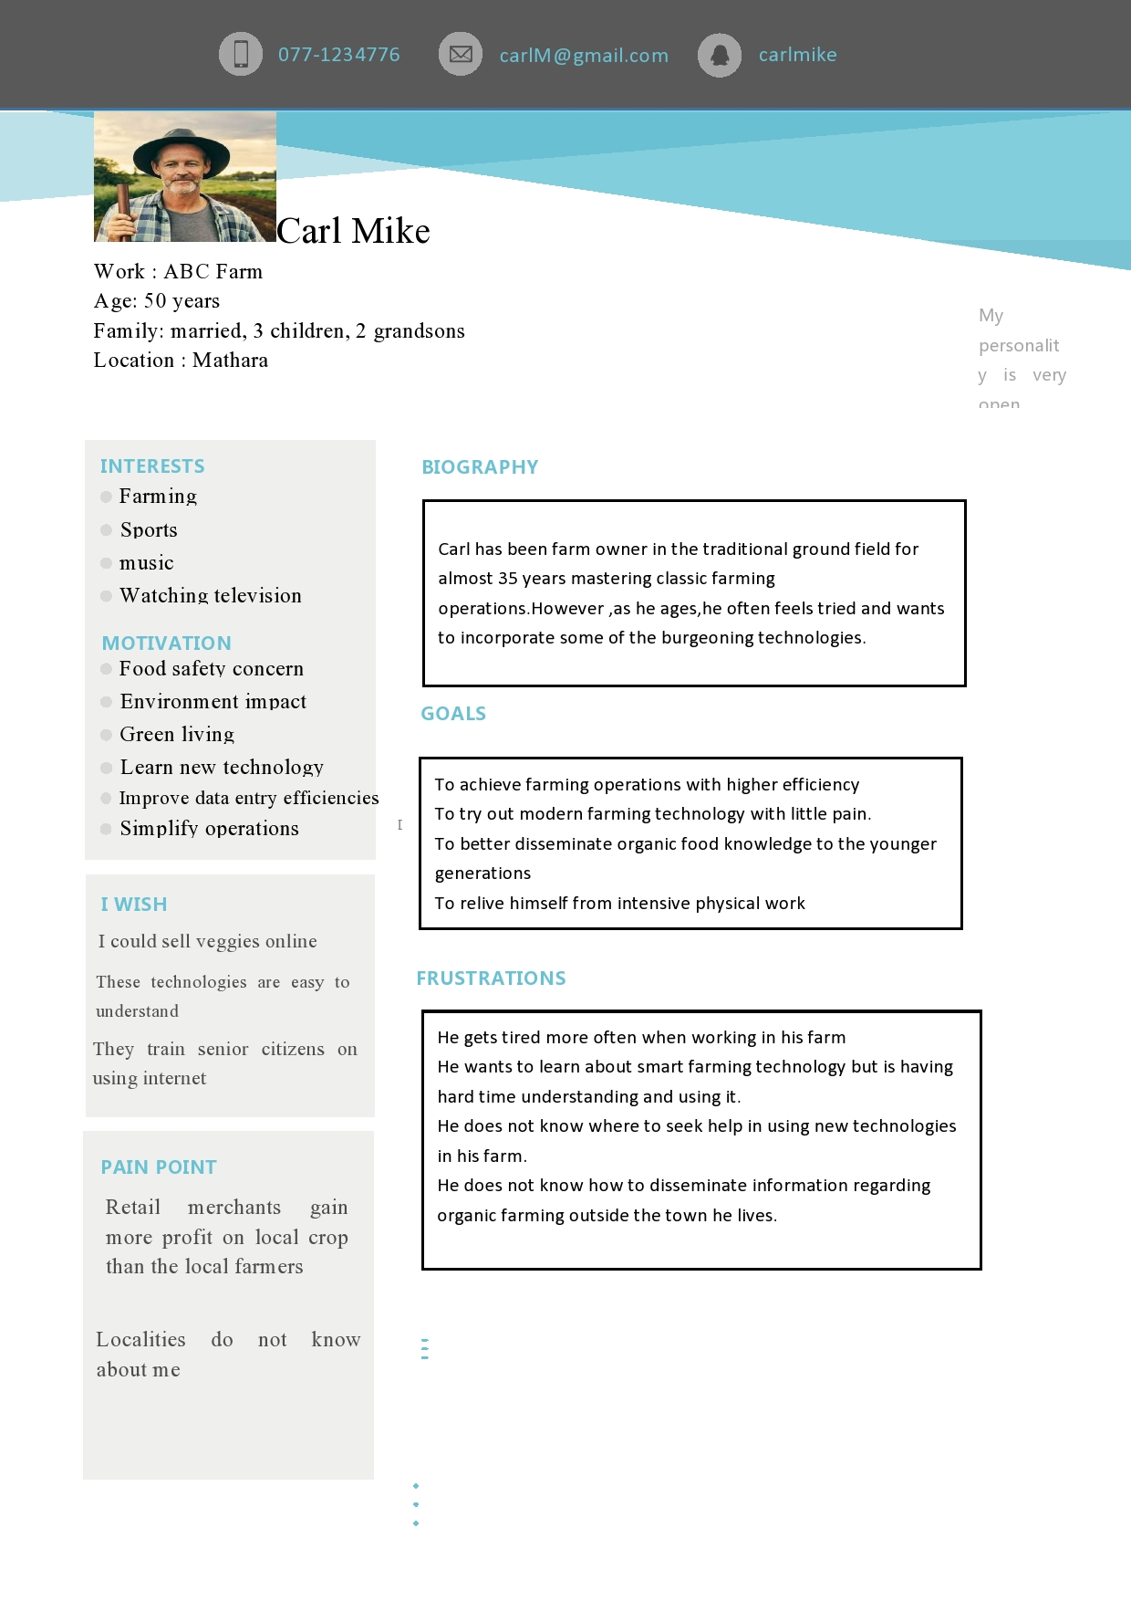

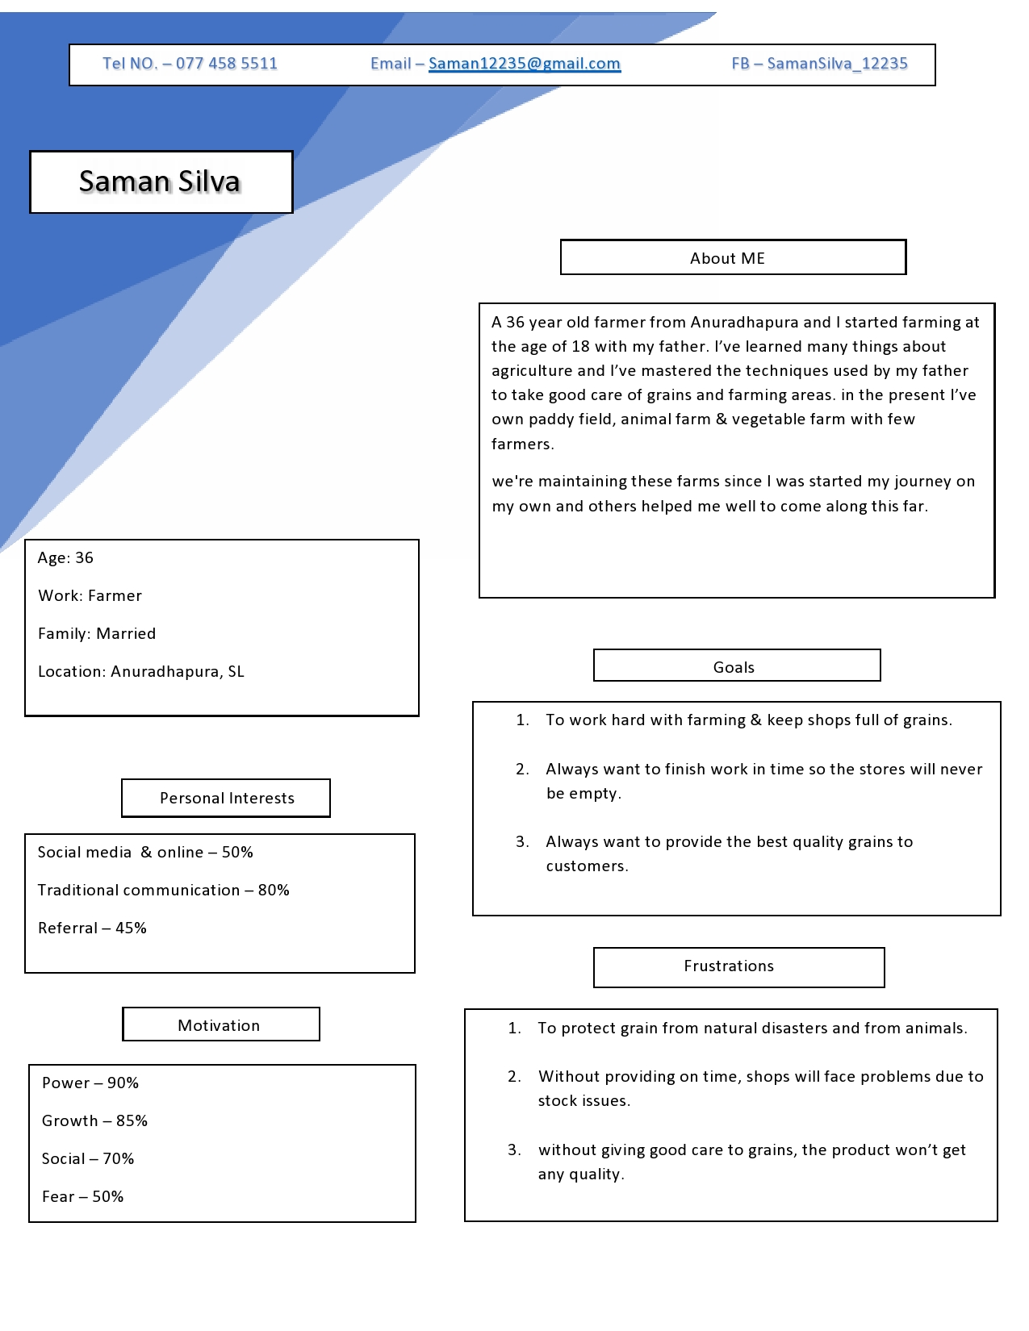

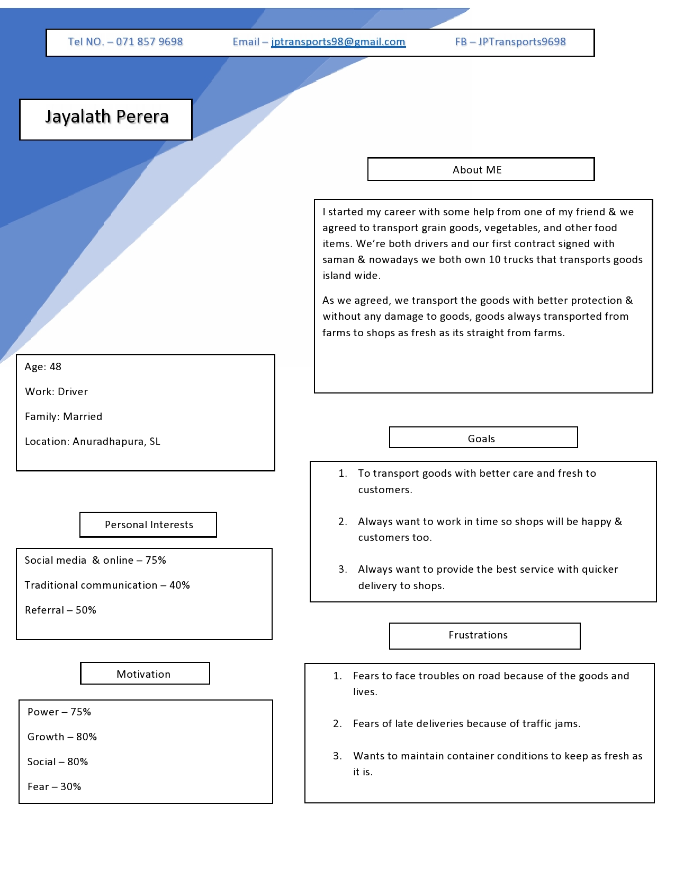

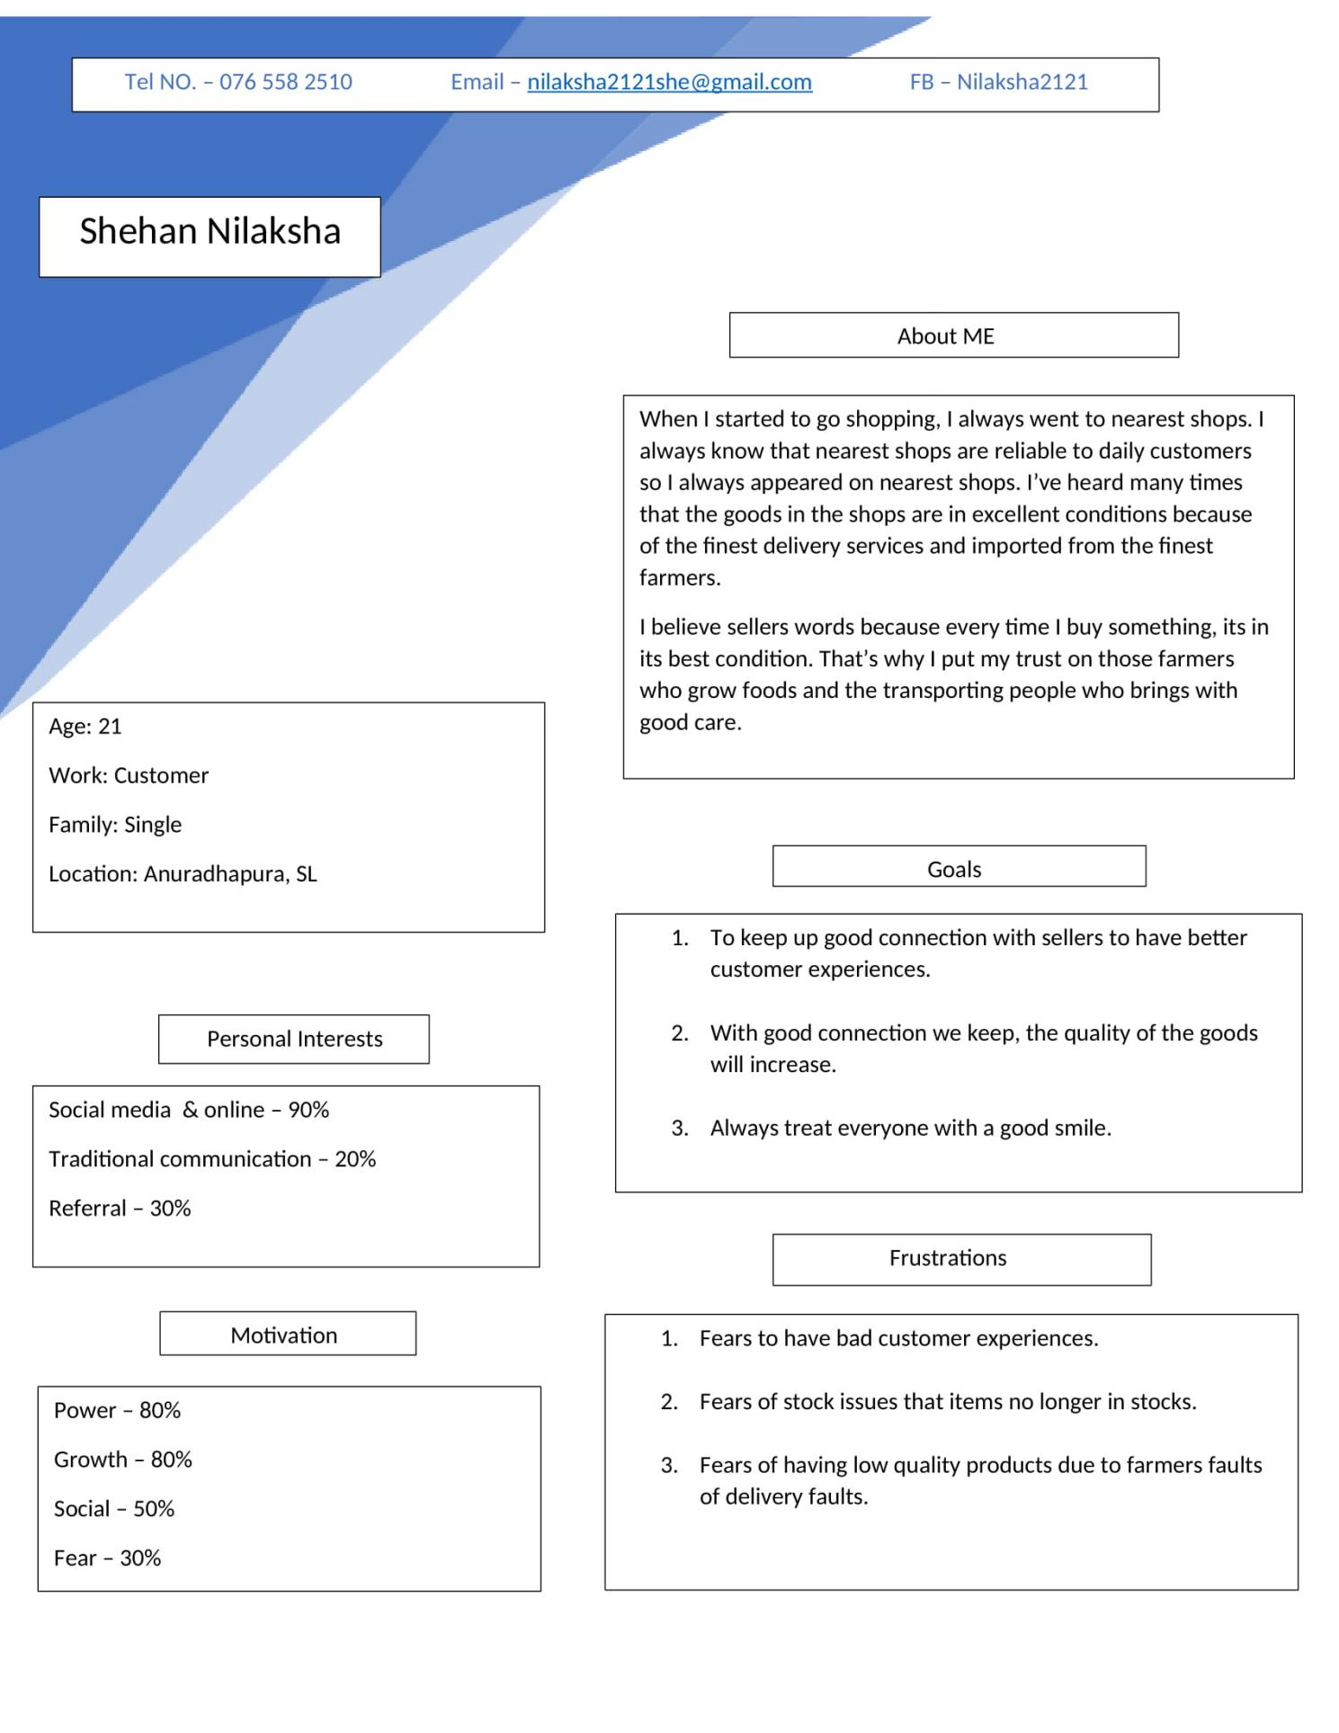

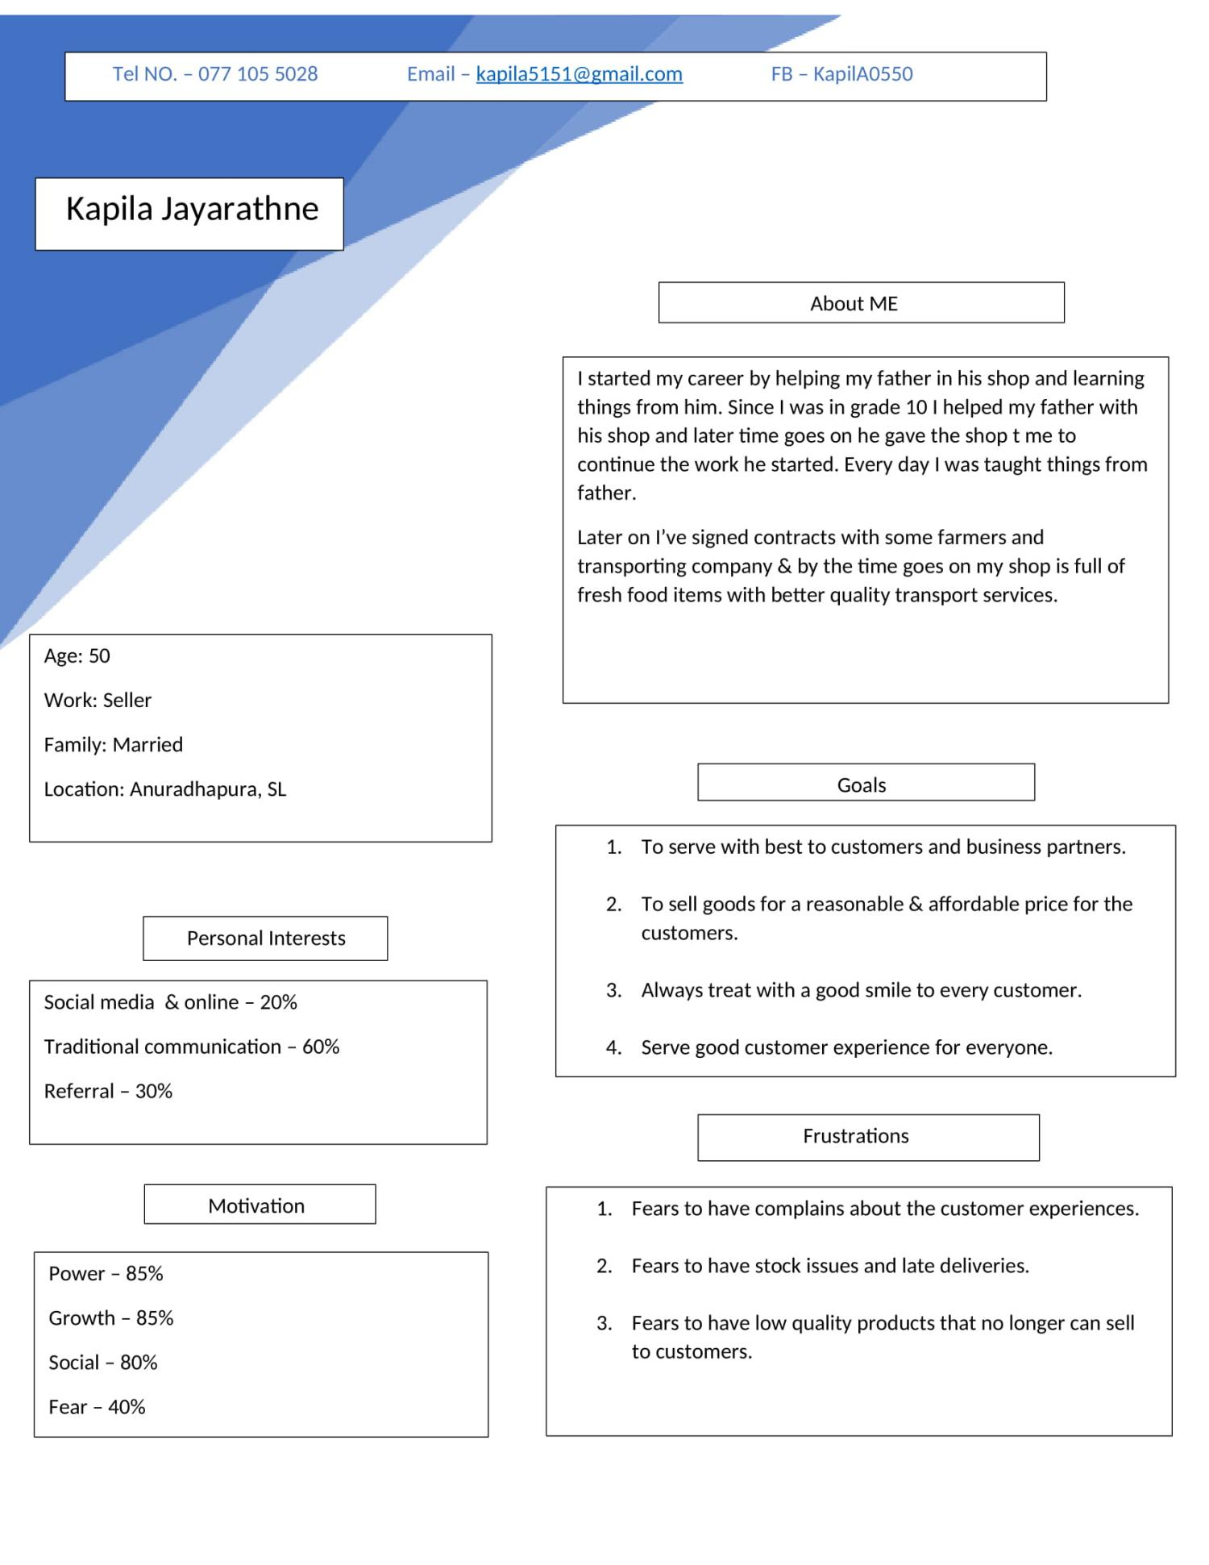

**Task analysis diagram**

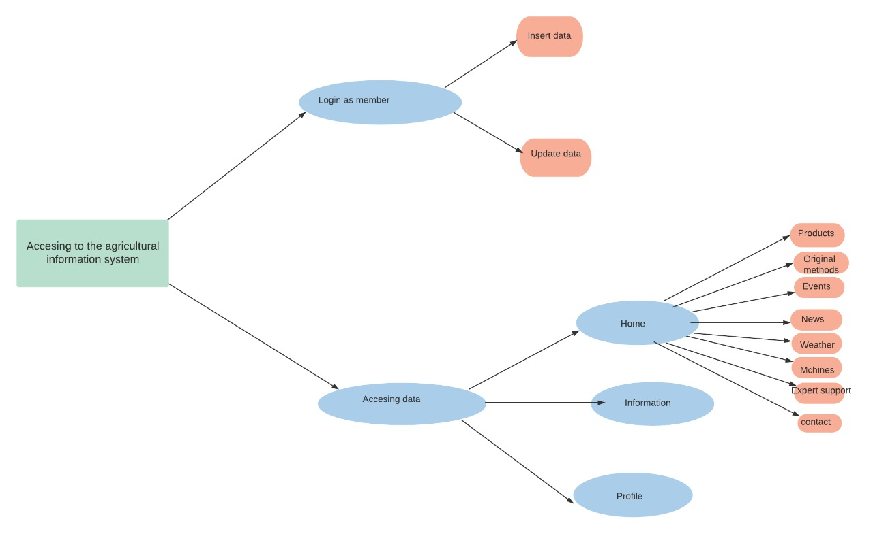

While examining farming data frameworks we should search for the wellsprings of data,

the substance of data, the trade (both get and move) of data, the degree of

the data contact, the level of convenience and the justification not utilizing it, the sort of

data required, etc.

**Lo-fidelity prototype**

**Main page**

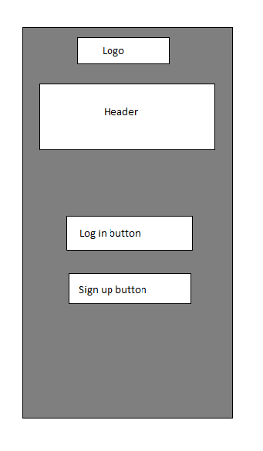

**Login page**

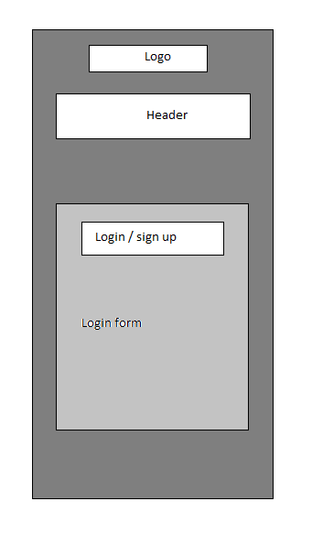

**Sign up page**

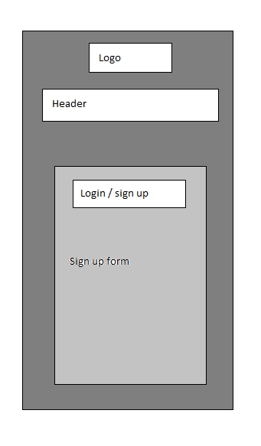

**Dashboard**

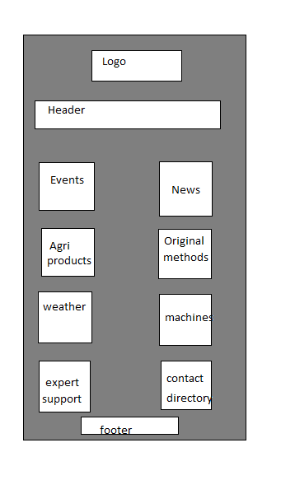

**Information page**

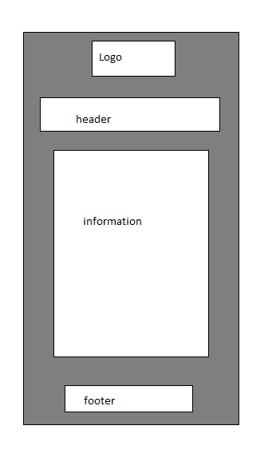

**User profile**

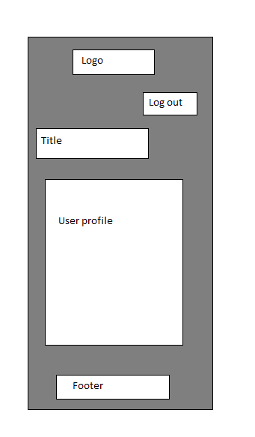

**Events**

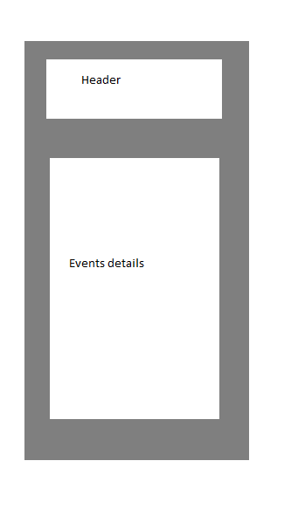

**News**

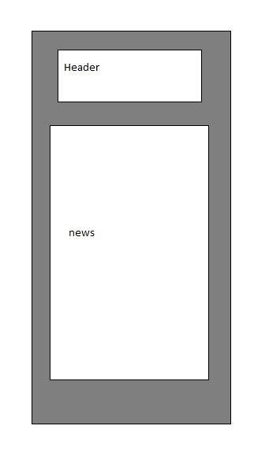

**Products - fruits**

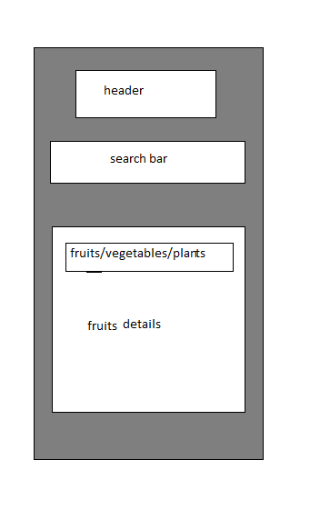

**Product - vegetables**

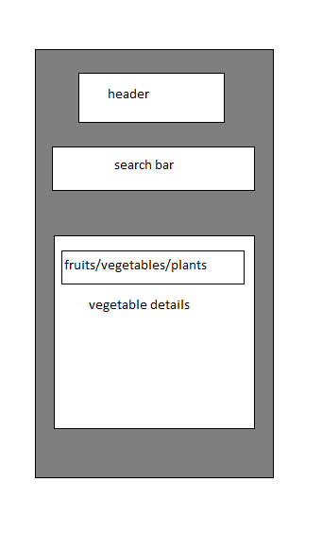

**Product - plants**

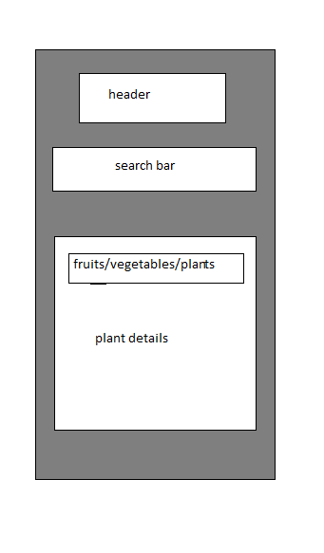

**Product view**

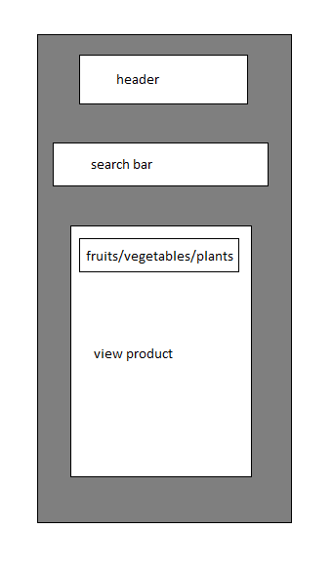

**Cart**

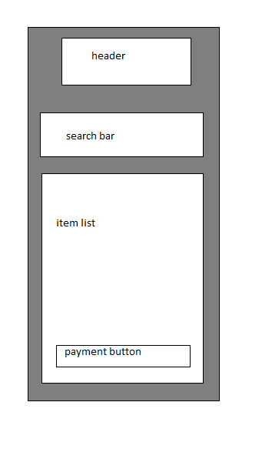

**Payment method**

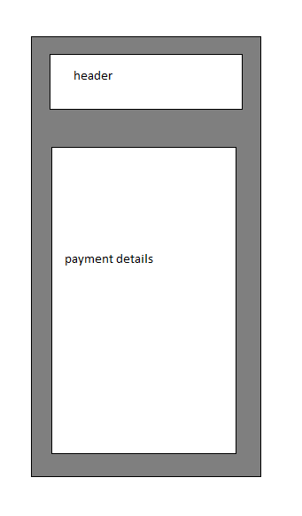

**Original methods**

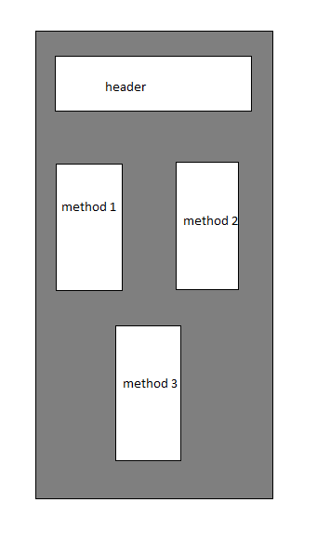

**Weather - today**

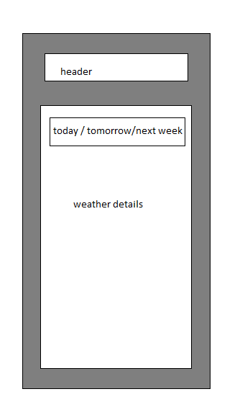

**Weather -tomorrow**



**Weather - next week**



**Machines**

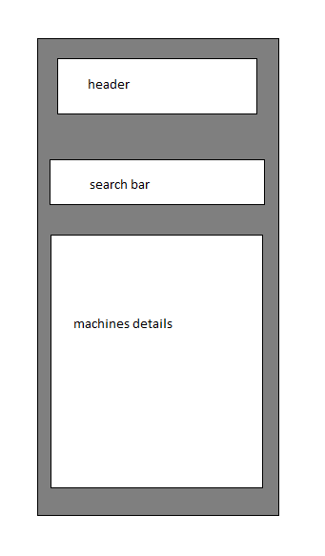

**Expert support**

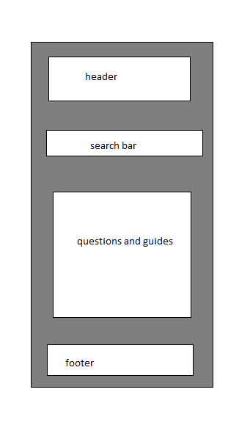

**Contact directory**

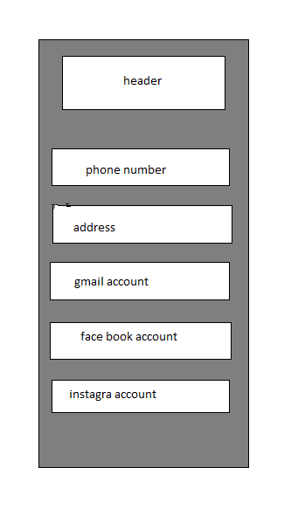

**Design principles used and justification**

There are three design principles used to design interface efficiency.

1. Learnability
2. Flexibility
3. Robustness

**Learnability**

Learnability is the ease with which a software application or product can be picked up and understood by users. The better the learnability of an application, the less training and time it will take for a person to use it.

**Familiarity:**

We use familiarity as the design principle of our system interface.When user wants to buy items with this system , he need to add their product list which he wish to get. In our interface there is a cart to add items. We use cart symbol and users familiar with this symbol and use it.



[This Photo](https://game-icons.net/1x1/delapouite/shopping-cart.html) by Unknown Author is licensed under [CC BY](https://creativecommons.org/licenses/by/3.0/)

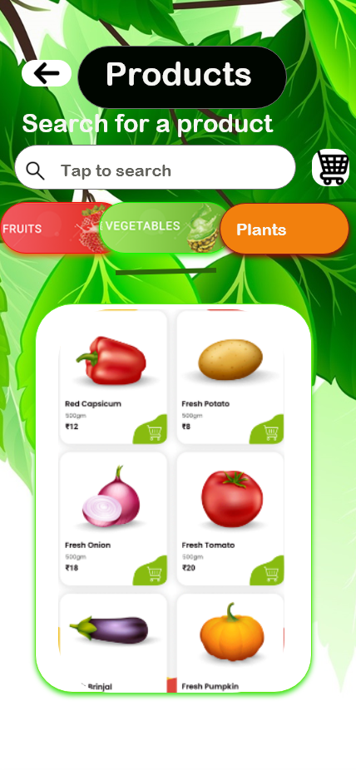

We use in login page and dashboard icons with text. User can understand icons without reading text.

**Consistency**

We use two types of sub categories in here.

Aesthetic - instead of written home button , written profile button we use icons.

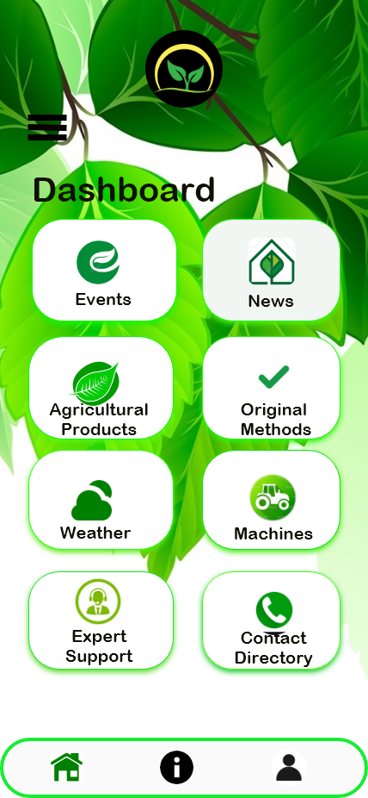

Functional - Slider option is one of function for that. In login page,there are login button and sign up button when we click on login button,it shows on black color and sign up button in white color, when user in sign up page sign up button will be black. It means user staying at sign up page.

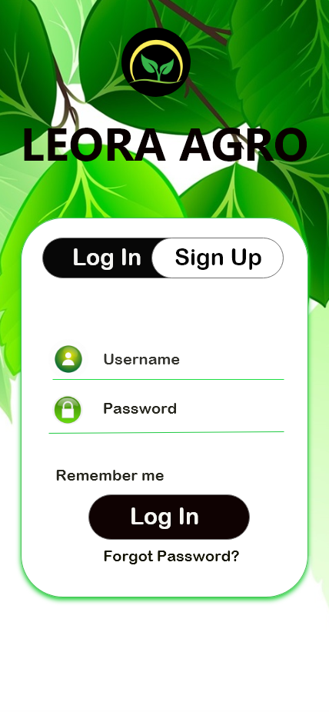

**Affordance**

It means can see the condition of the conceivable activity.

Searching bar - we use searching bar to search products.



Buttons -we use home page buttons,login page button,sign up page buttons,back buttons.

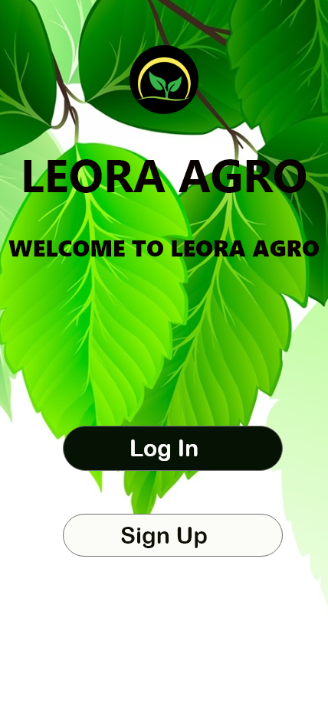

**Flexibility**

We use spell checker to check spellings. When user enter incorrect name on search bar it will show a message as no results found.

**Robustness**

We have contact us page and when user click on contact number it will redirect to the call , when we click on gmail or facebook it will show the relevant icons to go to these applications.

**Prototype**

Technical specification

We used adobe XD application for design our interfaces.

Screen design with descriptions

**Main page**



Thisis the first page of the agriculture information system.Its very user friendly.User can easily understand what to do.Login and sign up buttons are very clear to understand.We design a logo for our system .

**Login page**



Thisis the login page.When user click on the login button it will redirect to this page.It is very user friendly interface .We use clarity for this interface , anyone who use this interface can understand what is the function of this interface,This will increase the efficiency of the interface.We use eye comfort colors,big buttons to get user attention.In this login form we use icons to login details then user can recognize it quickly.

**Sign up page**

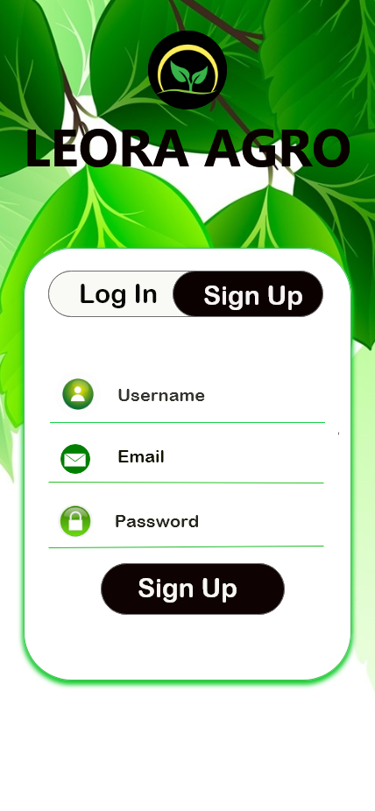

This issign up form.When user first came to our system,they don’t have account to log in.Then they must create an account .Sign up form will help to do that.When user click on the sign up button it will redirect to the sign up form.User can easily recognize about this interface, We use different colors different sizes font to get user attention.We design a logo to identify easily for user.back ground image also matches to the our purpose of this system.

**Dashboard**



This interface called dashboard UI.It represents the all buttons to go to other interface.User able to understand it very easily.When user click on the button it will goes to another page.Buttons use text and icon(sign language) about the button , so user can recognize it quickly.We divide into three parts of footer part ,it is also highlight.Buttons are big and place neatly to get user attention.

**Information page**

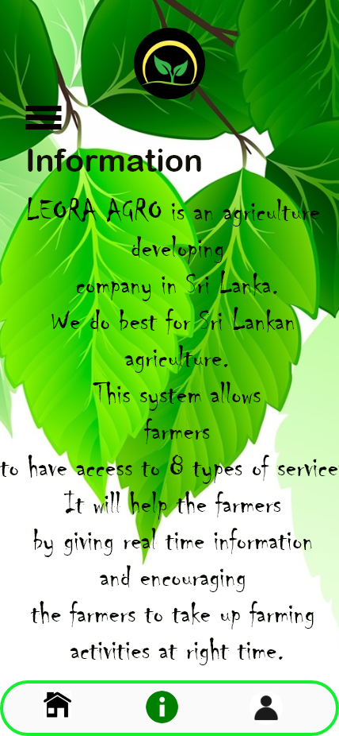

This isthe information interface.It will show the small paragraph about interface.User can get overall idea from this.We use different font family to title and description.

**User profile**

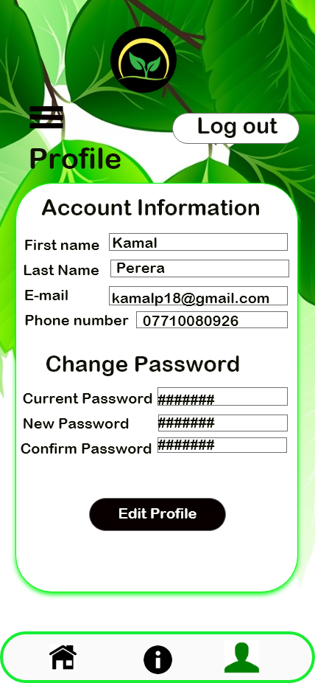

This is the user profile interface , when user login to our system their details will show there.user can change password as they wish. User can edit there profile.It is very useful feature .When user came to this page user able to understand whats the function of this UI .We use different color buttons for different functions.we can get user attention by doing that.

**Events**

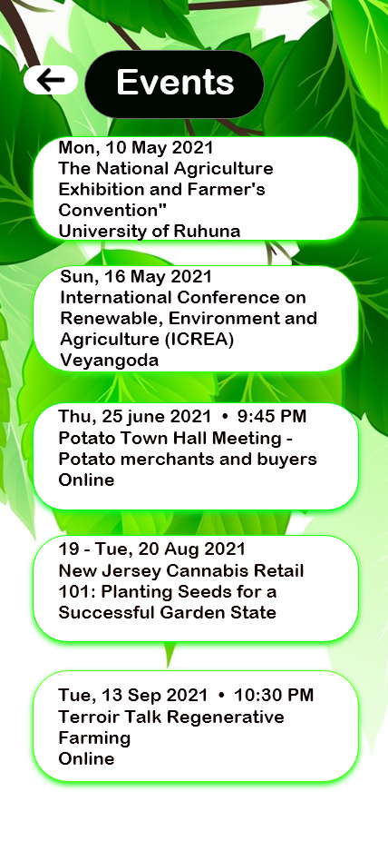

This is called as events interface.It shows us events which are going to held. These events are shown as very simple way which anyone can understand by reading them. We use attractive text field to show events. Its very neat interface.

**News**

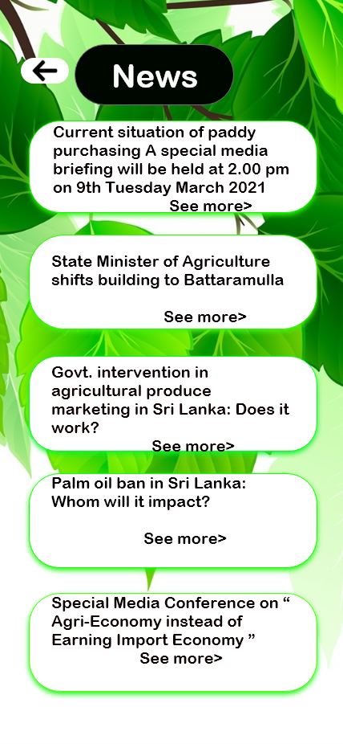

This is called as news interface .It shows us news about agriculture. These news are shown as very simple way which anyone can understand by reading them. We use attractive text field to show events. Its very neat interface.

**Products - fruits**

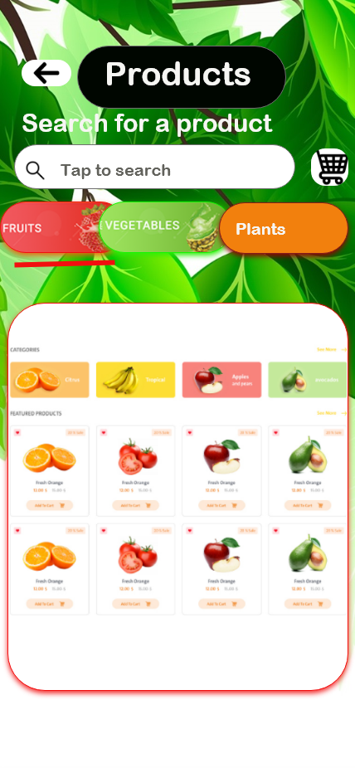

This is the product interface.Its show the products that user can buy.User can select item/items and add them to cart.In this interface user can search items.There are 3 categories of products , fruits,vegetables,plants.This interface shows about fruits.There is a cart symbol which user able to recognize easily**.**

**Product - vegetables**



This is the Product page of our agricultural information system. When user click on the vegitables button it will redirect to this vegitable page. . Here the search button allows the user to find the desired vegitables. Those things added to the cart. It is very user friendly interface .We use clarity for this interface , anyone who use this interface can understand what is the function of this interface,This will increase the efficiency of the interface.We use eye comfort colors,big buttons, large size font to get user attention.In this fruit product form we use icons to details then user can recognize it quickly. After creating the UI style guide. The overall user interface design was done to keep the website having a sense of good health and full of nutrition.

**Product - plants**

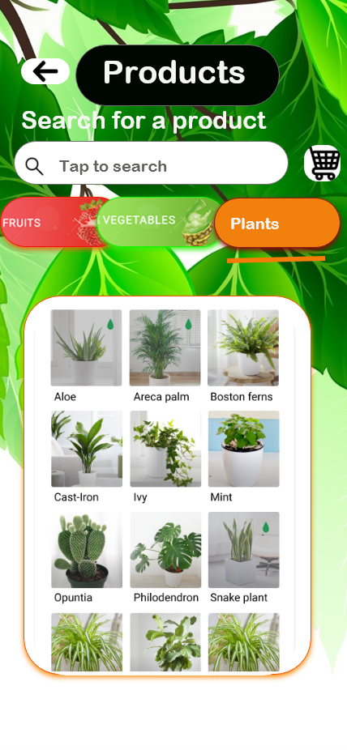

This is the Product page of our agricultural information system. When user click on the plants button it will redirect to this plant page. . Here the search button allows the user to find the desired plants. Those things added to the cart. It is very user friendly interface .We use clarity for this interface , anyone who use this interface can understand what is the function of this interface,This will increase the efficiency of the interface.We use eye comfort colors,big buttons, large size font to get user attention.In this fruit product form we use icons to details then user can recognize it quickly. After creating the UI style guide. The overall user interface design was done to keep the website having a sense of good health and full of nutrition.

**Product view**

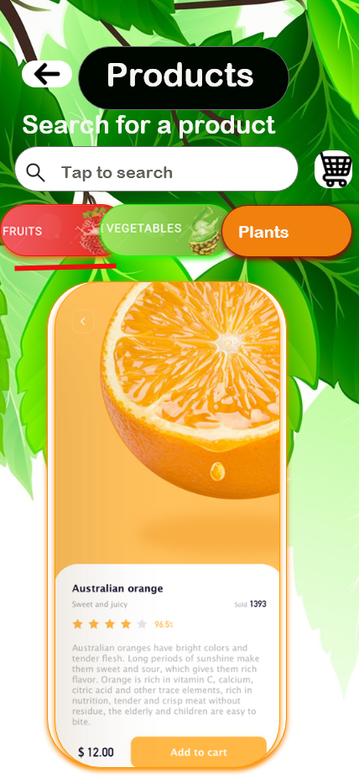

This interface can view the product by clicking on the product.It shows the all details of product. This interface is made very neatly, and get user attention. This interface is very colorful. We can search products by searching on search bar.

**Cart**

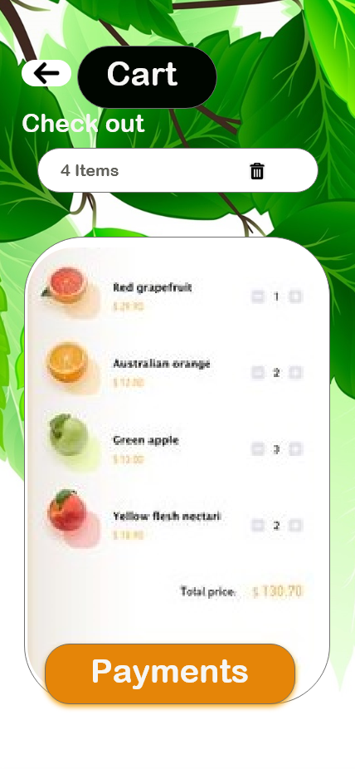

This is the cart page of our agricultural information system. When user click on the cart icon it will redirect to this vegitable page. . Those things added to the cart. It is very user friendly interface .We use clarity for this interface , anyone who use this interface can understand what is the function of this interface,This will increase the efficiency of the interface.We use eye comfort colors,big buttons, large size font to get user attention.In this fruit product form we use icons to details then user can recognize it quickly. After creating the UI style guide. The overall user interface design was done to keep the website having a sense of good health and full of nutrition.

**Payment method**

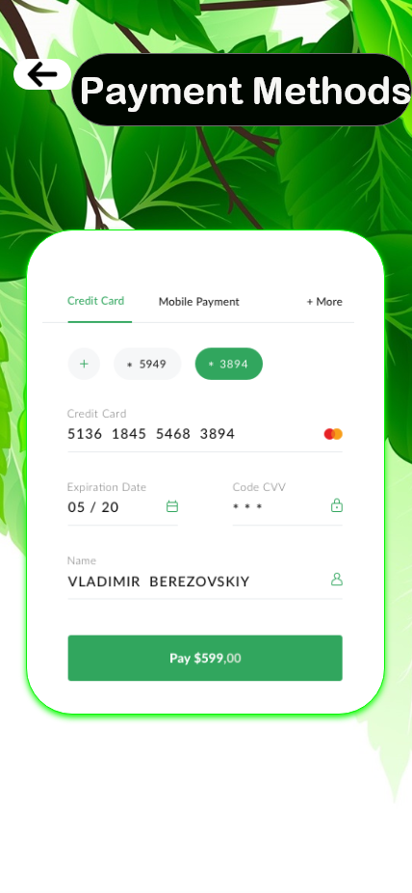

**Original methods**

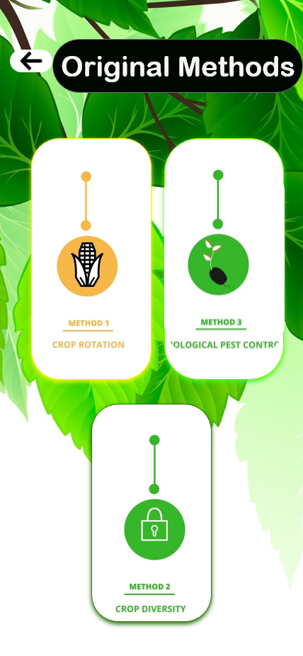

This is the payment methods page of our agricultural information system. uses a interface for the payment method selection during checkout. Notice how all the options are placed in close proximity so the user will perceive them as a collection and compare them to one another. Furthermore, the tabbed design makes it abundantly clear which option is currently selected and ensures that only form fields relevant to the current selection are displayed. Finally, Best Buy have made “Credit Card” the default choice so the user doesn’t have to stop and think but can simply proceed unless they want to make use of one of the other secondary payment methods accepted.

. It is very user friendly interface .We use clarity for this interface , anyone who use this interface can understand what is the function of this interface,This will increase the efficiency of the interface.We use eye comfort colors,big buttons, large size font to get user attention. We use eye comfort colors,big buttons, large size font to get user attention.In this fruit product form we use icons to details then user can recognize it quickly.

**Weather - today**

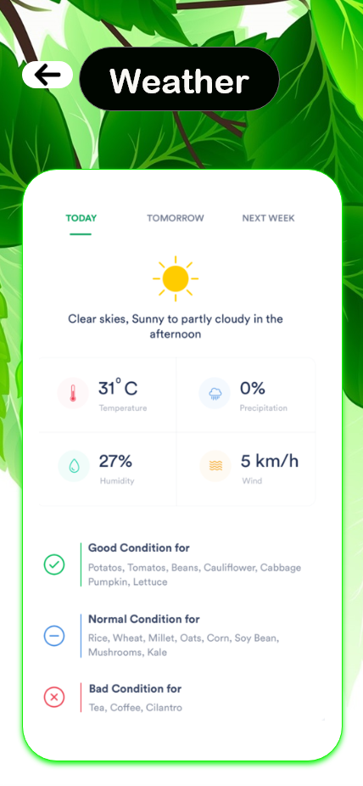

This includes weather details. This includes information related to weather. The temperature, precipitation, humidity and wind are shown in the panels. It can be viewed as a today, tomorrow, and next week by the bar chart. It is very user friendly interface .We use clarity for this interface , anyone who use this interface can understand what is the function of this interface,This will increase the efficiency of the interface.

**Weather -tomorrow**

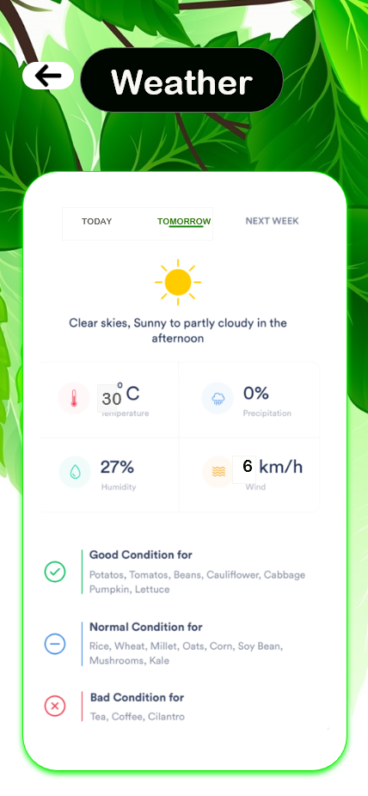

**Weather - next week**

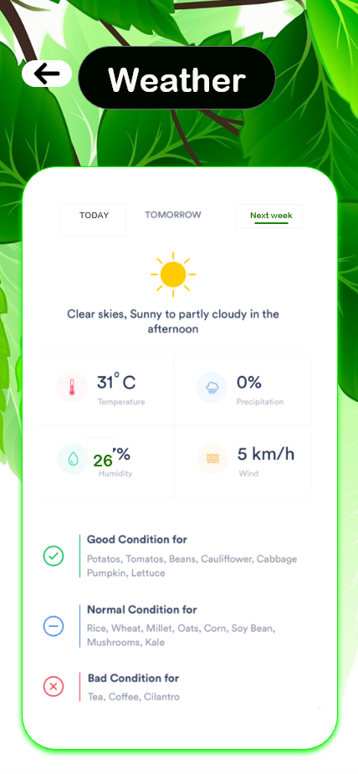

**Machines**

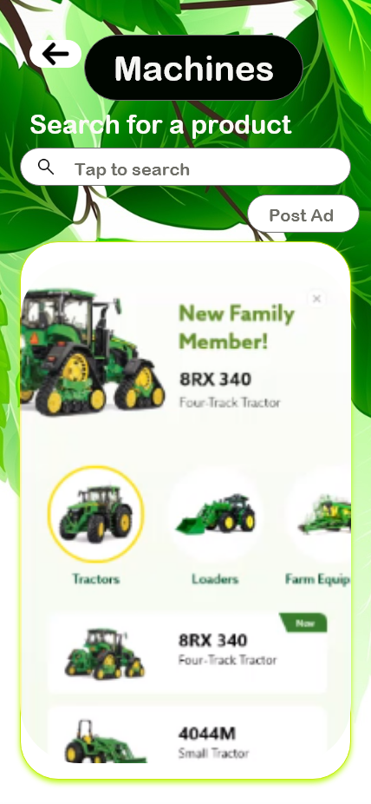

This is the machines page of our agricultural information system. When user click on the machines button it will redirect to this page. Here the search button allows the user to find the desired machines. It is very user friendly interface .We use clarity for this interface , anyone who use this interface can understand what is the function of this interface,This will increase the efficiency of the interface.We use eye comfort colors,big buttons, large size font to get user attention.In this fruit product form we use icons to details then user can recognize it quickly.

**Expert support**

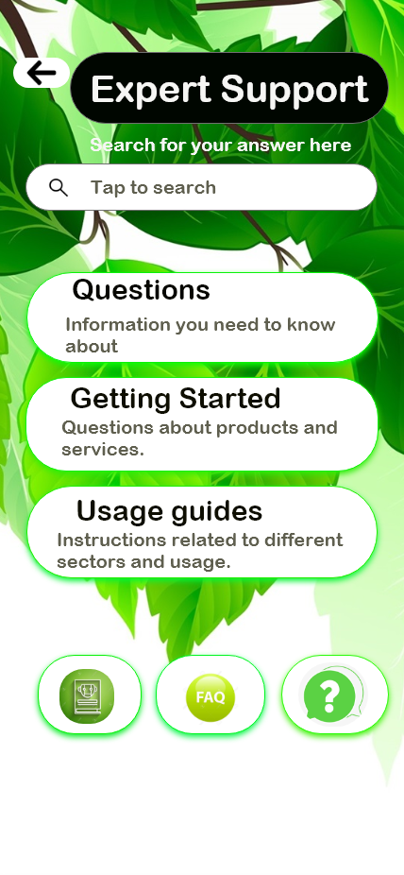

This is the expert support page of our agricultural information system. Here the search button allows the user to find the desired questions. The questions, getting started, and usage guides are shown in the panels. It is very user friendly interface .We use clarity for this interface , anyone who use this interface can understand what is the function of this interface,This will increase the efficiency of the interface.We use eye comfort colors,big buttons, large size font to get user attention.In this fruit product form we use icons to details then user can recognize it quickly.

**Contact directory**

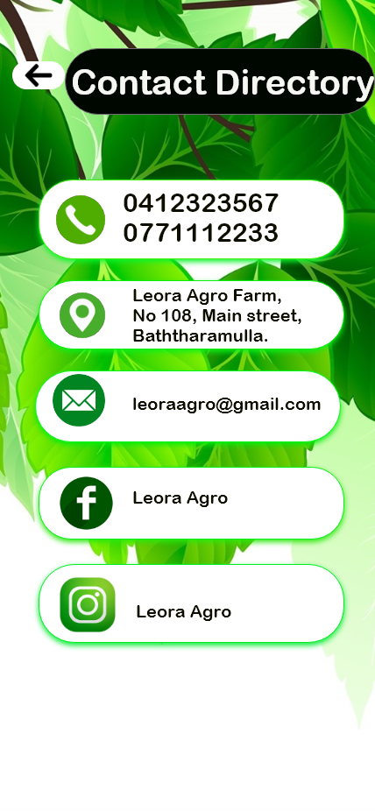

This id contact directory interface, this interface includes contact number,gmail account,face book account ,instagram account and address, when user wants to get more details about system user can contact us by using these details. These information are shown as very clearly and neatly. We use icons instead of texts to recognize user easily.

**Usability evaluation results**

Convenience ends up being a significant factor to decide if the clients utilize the new framework broadly or not. Convenience in horticulture is by all accounts a mind boggling issue as individuals are very little mindful about the advanced information accessible. Simplicity of such framework is a lot of required in horticultural situations to eliminate the advanced hole. It very well may be seen that improvement among rustic networks is discouraged. It tends to be seen that variables like lack of education, poor financial condition are answerable for it. Innovative tension towards IT foundation has gotten one of the basic issue. Absence of network to the wellsprings of data is one of the significant issue. This is the place where convenience appears. There are different strategies which can be utilized to discover the convenience of agrarian data framework. The designers of horticulture locales ought to know about their convenience level of their destinations. Accordingly, ease of use of rural locales is a significant examination. It will be beneficial in horticulture designing and lead to advance of ranchers. To discover the convenience, this paper utilizes different mechanized instruments. The assessment of sites is done through devices like Qualidator tool(which checks Usability, Accessibility, SEO and Quality(technical quality),Website Grader(which checks Performance, Mobile/UI, SEO, Security, Overall evaluation) and Seoptimer (which checks Performance, Mobile/UI,SEO, Security, Social, Page analysis).This paper assesses different agrarian destinations utilizing these devices.

**Conclusion**

By summing up, ICT based agricultural information system helps a lot to farmers in many ways. For example, farmers can check weather conditions whenever they need, events & news feed will keep farmers update with attest news relevant to their occupations, even they can learn things that relevant to agriculture, etc. for customers, this system will let them purchase food items & system will keep customers updated with latest news relevant to their products, etc.

This system will help not only customers to purchase items but help to learn about methods of agriculture & farming, every weather updates that farmers would need, even you can read & learn about food item information too. This could lead to build better communication between people who works in the relevant fields too. This also helps to teach farmers who doesn’t even know what’s ICT means and build strong relationship between agriculture and technology. To add more, user friendly interfaces will also lead to an attraction by users too. Overall, an all-rounder ICT based agricultural information system can be built with versatility for users.

**References**

* Lecture slides

**Contribution**

|  |  |  |
| --- | --- | --- |
| H.J.K.I. Wijerama | 10707417 | Main page,login page,sign up page,information page |
| K.L.D.Amupama | 10707129 | Agriculture products - fruits  User profile page,dashboard,cart |
| K.C.Heshan | 10707216 | Agriculture products-vegetable  Agriculture products view,events,news |
| U.R.K.Ukwatta | 10713401 | Weather today,weather tomorrow,weather nest week,expert support,Agriculture products - plants |
| N.N.D.G.Liyanage | 10707256 | Payment methods,original methods,machines,contact directory |